Tasks

Objective Questions:
1. What is the total number of attributes in the customer table?
Ans. The Customer Table includes 3 following attributes:
- CustomerID: A unique identifier for each customer.
- Customer Age: The age of the customer.
- Customer Gender: The gender of the customer (M for male, F for female)
2. How will you get the “Customer’s” ages in the “Order” tables according to customer IDs?
Ans. To get the Customer’s Ages in the Orders table according to Customer IDs, you need to
establish a relationship between the customers table and the orders table, then create a
calculated column or use the related field in your visuals.
- Establish a Relationship Between Tables by Drag and drop CustomerID from the customers table onto CustomerID in the orders table.
- We can now use the Customer Age field in the customers table to interact with the orders table by creating a calculated column using a DAX formula.
- Customers Age = LOOKUPVALUE(Customers[CustomerAge],Customers[CustomerID],Orders[CustomerID]

3. In analyzing the dataset with Power BI, ensure data cleaning to address inconsistencies and missing values before further analysis.
Ans. By the use of Power Query Editor, we clean the data for better analysis. First, we transform the data into power query editor and start cleaning our data.
- In data cleaning, I make sure that all the columns do not have any empty rows. After removing the empty rows, I changed the data type of order date and delivery date column to “Date” type.
- In the reason column, there were some empty rows without any reason for return of the product and for delivered products. So, I replaced those rows with “Unknown reason” for empty rows which have returned products and “Not Applicable” reason for empty rows whose products were delivered.
- By looking at the data set, there were 5 extra columns which are not necessary, so I removed them from the data set.
4. How can we calculate the total revenue generated by all the sales?
Ans. To calculate the Total Revenue, I have created a New Measure to sum the Sale Price
Column.
The DAX formula is Total Revenue = SUM(Orders[Sale Price]) which gives the answer Total Revenue of 107.24M.

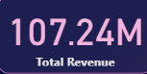

5. What is the total number of unique customers who made purchases each year? Is there any increase in the number over the years?
Ans. Extract the Year from Order Date:
- Transform Data > Order Date > Add Column > Date > Year
- This step has created a new column name Year representing the year of the order.

Create a Measure for Unique Customers Per Year:
- Data View > Order Table > New Measure
- Entered the DAX formula
Unique Customers = DISTINCTCOUNT(Orders[CustomerID])

Visualization:
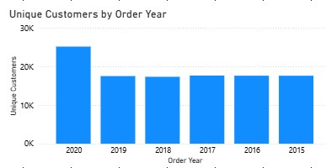
Observations:
- The unique customer count shows a steady increase from 2019 to 2020, suggesting effective marketing strategies or an expanding product range that attracts new customers.
- A slight decline in customer count from 2017 to 2018 may indicate potential issues such as product availability, pricing changes, or increased competition
6. How can we determine the total number of unique products available in the company?
Ans. Followed these steps:
- Data View > Order Table > New Measure
- Entered the DAX formula:
Unique Products = DISTINCTCOUNT(Orders[Product])

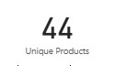

7. What is the average number of days it takes for products to be delivered, get the metric for only the delivered orders.
Ans. Followed these steps:
- Created a New Column for Delivered Days
- Data View > Select Orders Table > New Column
- Enter the DAX formula:
- Delivered Days = DATEDIFF(Orders[OrderDate], Orders[Delivery Date], DAY)
- This formula calculates the number of days between the OrderDate and Delivery Date.
- Filter for Delivered Orders
- New Measure
- Enter the DAX formula:
Avg Delivery Days = CALCULATE(AVERAGE(Or ders[Delivered Days]),Orders[Status] = "Delivered")
- This measure calculates the average delivery duration for orders where the status is "Delivered."

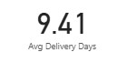

8. Which products, categories, and subcategories are the most popular?
Ans. Popularity by Order Quantity:
- Table View > New Measure
- TotalOrderQuantity = SUM(Orders[Order Quantity])

a) For Most Popular Products:
- Add a Table Visual to the canvas
- Drag the Product column into the table
- Drag the TotalOrderQuantity
- Sort the table by TotalOrderQuantity in descending order.

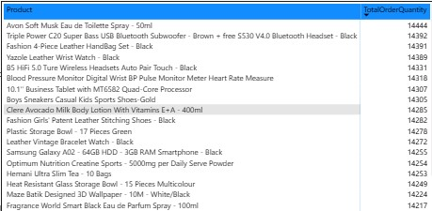
b) For Most Popular Categories :
- Add a Table Visual to the canvas
- Drag the Product Category column into the table
- Drag Total Order Quantity
- Sort the table by TotalOrderQuantity in descending order.
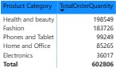
c) For Most Popular Subcategories
- Add a Table Visual to the canvas
- Drag the Subcategories column into the table
- Drag Total Order Quantity
- Sort the table by TotalOrderQuantity in descending order.
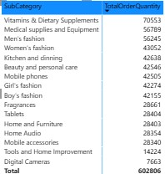

9. Which products have seen an increase or decrease in sales over the year?
Ans. To analyse which products have seen an increase or decrease in sales over the years,
I followed these steps:
- Create a measure for Previous Year Sales:
PreviousYearSales
=CALCULATE([TotalRevenue],FILTER(Orders,Orders[OrderDate].[Year] = MAX(Orders[OrderDate].[Year]) -1))
- Create a measure for Sale Change
SalesChange = [Total Revenue] - [PreviousYearSales]

Matrix Visualization
- Rows – Product
- Values – Total Revenue, PreviousYearSales, SalesChange

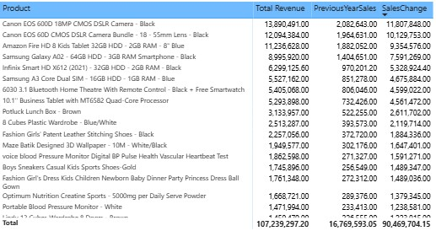

10. While modeling the data relationships, what will be the type of relationship between the customer ID of Orders and customer tables?
Ans. While modelling the data relationships, the type of relationship between the customer ID of Orders and Customer table is “Many To One” relationship.
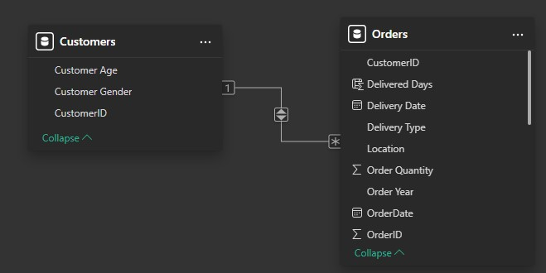

11. How have you handled the null values in the data?
Ans. Using Power Query Editor to Filter or Remove/Handling Null Values
- Go to Power BI Desktop
- Click on Transform Data
- Select the column where I’ve to handle null values
- Click on the Filter Dropdown
- If null values exist, then uncheck "(null)" in the filter
- This removes rows containing null values
- Reason: Replace null values with "NA" in Power Query using Replace Values
Removing Blank Rows:
- In Power Query, select the dataset
- Click on Transform > Go to Row
- Check if there are any fully blank rows
- Click Remove Rows > Remove Blank Rows
- This removes any row where all columns are blank
12. Were there any data format issues in the data, and if there were/are how you would handle them?
Ans. In our data, there was no need to change the data types. If there was such an issue to format the datatypes then I can check and transform data types in the Power Query editor.

13.When we add a column in Power Query what’s the code that comes in M language in the formula bar? What do you know about M-query?
Ans. M Query is the functional language used in Power Query to transform and prepare data before loading it into the Power BI data model.
- When we add a column in Power Query, Power BI generates M query that reflects the action.
- Example of M Code for Adding a Column
= Table.AddColumn(Source, "NewColumnName", each [ExistingColumn] * 2, type number)
Explanation:
- Table.AddColumn: A function that adds a new column to a table.
- Source: Refers to the table or step we’re working with.
- "NewColumnName": The name of the new column.
- Each [ExistingColumn] * 2: The calculation or logic for the new column (in this case, doubling the values of ExistingColumn).
- Type number: Specifies the data type of the new column (e.g., number, text, date).
14. Identify the top 5 most valuable customers using a composite score that combines three key metrics: (SQL)
- Total Revenue (50% weight): The total amount of money spent by the customer.
- Order Frequency (30% weight): The number of orders placed by the customer, indicating their loyalty and engagement.
- Average Order Value (20% weight): The average value of each order placed by the customer, reflecting the typical transaction size.
Ans. The Composite Score will be calculated as:
(0.5 * TotalRevenue) + (0.3 * OrderFrequency) + (0.2 * AvgOrderValue)

Query:
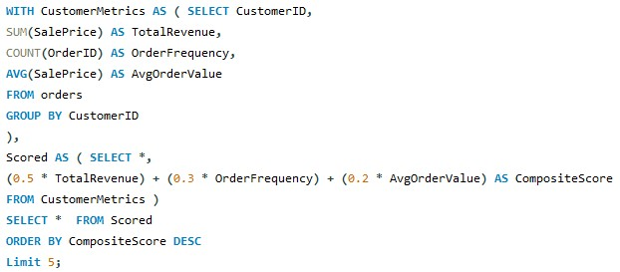

Output:
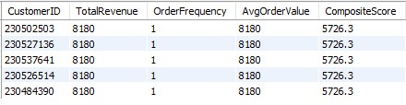

15. Calculate the month-over-month growth rate in total revenue across the entire dataset. (SQL)
Ans. Query:
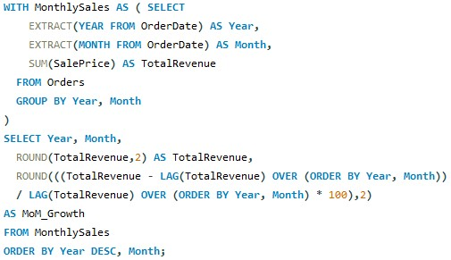
Output:
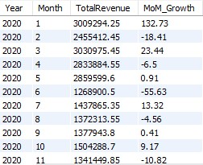

16. Calculate the rolling 3-month average revenue for each product category. (SQL)
Ans. Query:
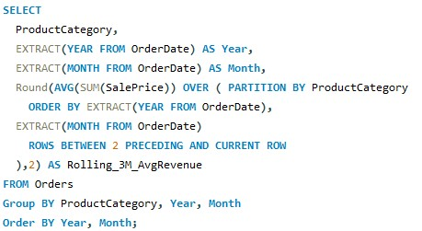
Output:
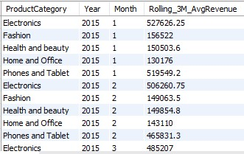

17. Update the orders table to apply a 15% discount on the `Sale Price` for orders placed by customers who have made at least 10 orders. (SQL)
Ans. Query:
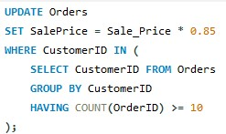

18. Calculate the average number of days between consecutive orders for customers who have placed at least five orders. (SQL)
Ans. Query:
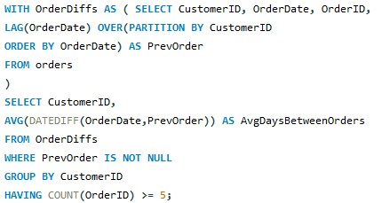
Output:
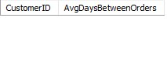

19. Identify customers who have generated revenue that is more than 30% higher than the average revenue per customer. (SQL)
Ans. Query:
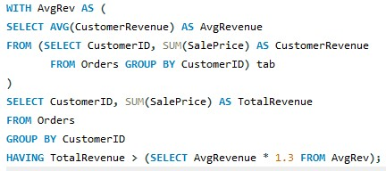
Output:
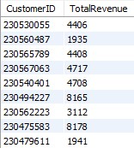
20. Determine the top 3 product categories that have shown the highest increase in sales over the past year compared to the previous year. (SQL)
Ans. Query:
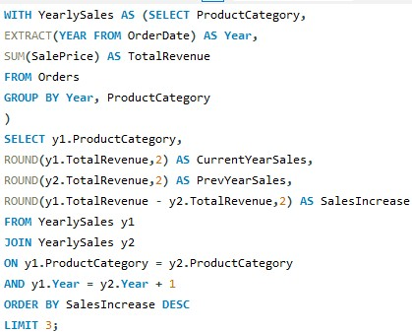

Output:
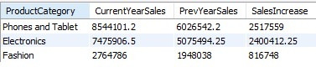

Subjective Question:
1. Explain the revenue breakdown by year and by-product. Evaluate how different products contribute to annual revenue and come up with suggestions to increase the sales of the low-selling items.
Ans. Reference for revenue breakdown by year:
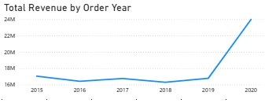
- Reference for revenue breakdown by product:

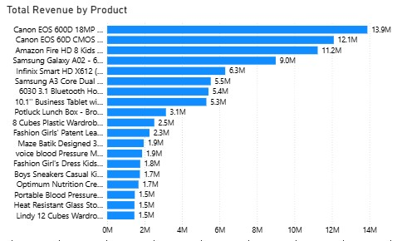

- Strategies to Increase Sales of Low-Selling Items:
- Combine low-selling products with top-performing items as part of a bundle deal.
- Provide special discounts on low-selling items for a limited time to boost demand.
- Place low-selling products in the "Recommended for You" or "Trending Now" section.
- Compare pricing with competitors and adjust accordingly.
- Encourage customers to leave positive reviews for underperforming items.
- Retarget interested customers who viewed but didn’t purchase low-selling products.
- If a product has low sales in certain locations, check if it's due to stock unavailability. Use zone-wise analysis to optimize inventory distribution.

2. How many products were returned? Use a DAX function to get this metric. Examine the possible reasons for returns and consider how this metric could indicate improvements in product descriptions or quality control.
Ans. Create a Measure for Returned Products
- Returned Products = CALCULATE(COUNTROWS(Orders), Orders[Status] = "Returned")
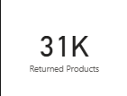
- Analyse Reasons for Returns
- The Reason column provides insights into why products were returned.
- Create a Count of Each Return Reason by following formula:
- Returned Products = CALCULATE(COUNTROWS(Orders), Orders[Status] = "Returned")])
- Insert a Table Visual.
- Drag Reason and ReturnProductsCount into the table.
- Sort the table in descending order to see the most common return reasons.
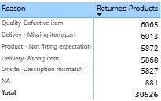
Insights from the data to Examine the possible reasons for returns and consider how this metric could indicate improvements in product descriptions or quality control:
a) Quality - Defective Item
Issue:
- “Quality-Defective Item” (6,065) is the most common reason for returns.
- Faulty manufacturing or improper handling may be leading to damaged goods.
Solution:
- Implement stricter quality checks before shipping.
- Use AI-driven quality control in warehouses to detect product defects.

b) Delivery - Missing Item/Part
Issue:
- Items with missing parts indicate incomplete packaging or supply chain issues.
Solution:
- Add checklists at packaging stations to confirm completeness.
- Implement barcode scanning to verify that all required parts are included.
- Add checklists at packaging stations to confirm completeness.
c) Product - Not Fitting Expectation
Issue:
- Customers return items because they don’t match their expectations, possibly due to misleading descriptions or images.
Solution:
- Improve product descriptions by including detailed specifications.
- Use high-quality images & 360-degree product views.
- Add customer reviews and Q&A sections to clarify doubts.
- Provide a "Size Guide" or "Comparison Tool" for apparel and electronics.
d) Onsite - Description Mismatch
Issue:
- Customers are getting items that do not match what was shown online.
Solution:
- Cross-check product listings with actual items before listing.
- Require vendors to submit real customer photos instead of only stock images.
e) Delivery - Wrong Item
Issue:
- Incorrect products are being sent, possibly due to warehouse mislabelling or human error.
Solution:
- Improve order verification systems before shipment.
- Introduce a "Live Order Check" where customers can confirm their order before shipment.

3. Whenever a customer goes to Amazon, they’ll filter the most rated products to buy the better category. Can you verify this using any visualization or table that the ratings of products impact their sales value?
Ans. Visualization :
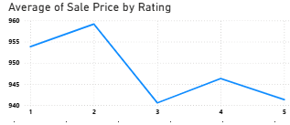

Insights and Targeted Marketing Strategies:
- Customers are likely to filter for highly rated products, as indicated by the significant sales increase for products rated above 4. This suggests that ratings significantly influence purchasing decisions.
- Focusing marketing efforts on products with higher ratings can enhance sales.
- Products with lower ratings should be analyzed for potential improvements like customer reviews can provide insights into issues that need addressing, which can boost ratings as well as sales.
4. Investigate how revenue distribution varies across different locations. Explore which geographical areas contribute most to sales and consider the strategic implications for regional marketing and distribution efforts. How might location-based trends inform the company's market segmentation and resource allocation approach?
Ans. Visualization :
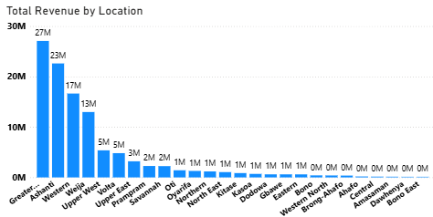

Insights and Targeted Marketing Strategies:
- Greater Accra stands out as the highest revenue-generating region with 27M. This suggests that it is a critical market for business.
- Other contributors like Upper West and Eastern regions also generate significant revenue, indicating multiple strong markets.
- Areas from Oti show relatively low revenues as shown above. This highlights potential areas for improvement or targeted marketing efforts.
- Location-based trends can significantly inform a company's market segmentation and resource allocation strategy in several ways.
- By analysing revenue data by location, the company can identify which regions contribute the most to overall sales.
- Variations in purchasing behaviour across locations can lead to the development of localized versions of products or services to better meet customer expectations.
- Understanding geographical revenue distribution can help in planning logistics and distribution strategies, ensuring that high-demand areas are well-stocked while optimizing inventory levels in less productive regions.
5. Determine which month could benefit from enhanced promotional offers to boost sales. Can you suggest some targeted marketing strategies here?
Ans. Visualization :
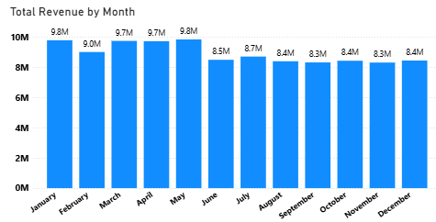
Insights:
- Revenue peaked in January and May at 9.8M, showing strong early-year performance.
- A noticeable drop begins in June (to 8.5M), marking a slowdown of around 13% from earlier highs.
- From August to December, revenue remains steady around 8.3M–8.4M, indicating a consistent but lower performance.
Targeted Marketing Strategies:
a) Discount & Cashback Offers:
- Offer higher discounts on slow months.
- Implement limited-time cashback offers to encourage spending.
b) Prime Membership Incentives:
- Provide extra perks for Prime members, such as free express delivery in low-sales months.
- Offer exclusive early access to deals.
c) Personalized Promotions:
- Use customer purchase history to send customized discount coupons.
- Offer bundle deals based on customer preferences.
d) Festive & Event-Based Marketing:
- Align promotions with local festivals or shopping holidays.
- Like October for Halloween promotions, November and December Focusing on Black Friday, Diwali last-minute gift deals, "12 Days of Christmas" offers, gift bundles.
e) Referral & Loyalty Programs:
- Encourage existing customers to refer friends with referral discounts.
- Offer loyalty points redeemable in the next purchase.
6. Identify which products may require increased marketing efforts. Which items have high prices yet underperform in sales?
Ans. Visualization :
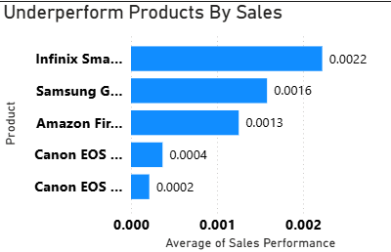

- From the above Bar chart, these are the 5 underperformed products which may require increased marketing efforts.
- First I calculated sales performance by using DAX formula “DIVIDE” i.e. Sales Performance = DIVIDE(Orders[Order Quantity], Orders[Sale Price]).
- With the average of sales performance against products by using Bar chart and using filters for lowest 5 products I got the results.
- Despite having high price, the sales of these products are very low.

7. Assess which products should have discounts. How can targeted incentives drive sales and customer loyalty for specific products?
Ans. Visualization :
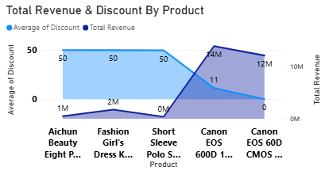
- As we see in the above Area chart, these are the products with lowest discounts. If we have more discounts for these products, we can drive more sales which will result in more revenue. I calculated discount for the products using Discount = Orders[TotalCostPrice] - Orders[Sale Price]. With average of discount in y- axis, total revenue in secondary axis and products in x-axis, we can see the comparison.
8. Come up with a loyalty program to benefit the company’s customers. From the available lot of customers come up with strategies to bucket them and provide benefits under different loyalty programs.
Ans. Visualization :
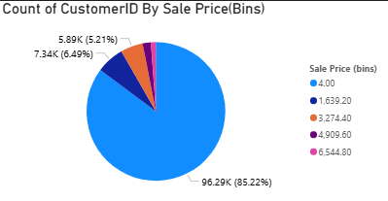
- I have grouped the customers into 5 categories based on the spending capacity.
- VIP Program for High End Customers - These customers are the highest spenders with minimum sale price of 6544.8. We can provide premium services tor these customers like early access to big sales.

- Reward Points Premium Customers - Premium customers minimum spending amount is 4909.6. Giving points on every spend will be a reward for their loyalty.

- Special Discounts for Standard Customers – Standard customers usual spend minimum of 3274.4. Giving rewards on special occasions like birthdays will make the customers happy.

- Card discounts for Economy Customers – Customers with minimum spending amount of 1639.2 are the economy customers. We can provide Card discounts for them if they pay money through their debit or credit cards.

- Cashback and High Discounts for Budget Friendly Customers – These customers mainly focus on their budget. If the sale price is less then only, they will purchase the products. So, giving cashback and high discounts will attract these customers.
9. Using the DAX functions Calculate and a row iteration DAX function calculate the total sales for the Product Category “Fashion” and delivery type “Shipped from Abroad”. What are the other types of DAX functions you have used in the project?
Ans. Create a Measure for Fashion_Abroad_Sales :
Fashion_Abroad_Sales = CALCULATE( [Total Revenue], Orders[Product Category] =
"Fashion", Orders[Delivery Type] = "Shipped from Abroad" )
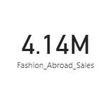
Other DAX Functions Used in the Project are:
- Aggregation Functions: SUM, AVERAGE, COUNT
- Filter Functions: FILTER, ALL
- Time Intelligence Functions: DATEADD, TOTALYTD, SAMEPERIODLASTYEAR
- Logical Functions: IF, AND
- Mathematical Functions: DIVIDE, ABS
- Statistical Functions: RANKX
- Iterative Functions: SUMX, AVERAGEX
- Information Functions: ISBLANK
10. Wait Times Correlated with Demographics and Care: Explore how average wait times vary across different product categories to optimize scheduling and staffing.
Ans. Wait Time Correlated with Demographic(CustomerAge)
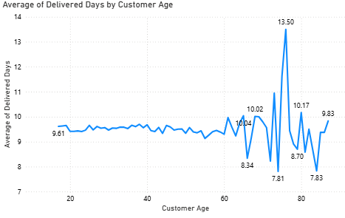
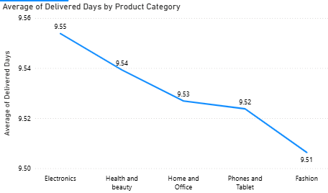
- Here Wait Time means Delivery Time from my dataset. In the first Line chart, we can see how wait time correlate with demographic i.e. Customer age. In the graph, above 60 years age group the average delivery time varies from 8.34 days to 13.50 days. Below 60 years there is no much variation in the average delivery time.

- In the second Line chart, we can see how average wait time vary across different product categories. The analysis shows minimal variation in average delivery times across product categories, ranging narrowly from 9.51 to 9.55 days. Electronics have the longest delivery time (9.55 days), while Fashion products are delivered slightly faster (9.51 days), indicating a consistently efficient delivery process across all categories.

11. Explore if there is any relationship between the Delivery type and waiting time between ordering and receiving an item.
Ans. Visualization :
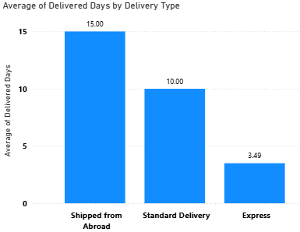

Insights:
- Shipping from Abroad has the highest average wait time (15.0 days), indicating that international shipping or logistics may be causing significant delays. This could be due longer transit times, or limited shipping options.
- Standard Delivery has a moderate wait time of 10.0 days, suggesting that domestic deliveries take a reasonable amount of time but may still have room for improvement.
- Express Delivery has the shortest wait time (3.5 days), which is ideal for customers who value quick delivery. However, since it’s significantly faster, it might suggest that customers are willing to pay a premium for faster service.
Recommendations:
- Partner with faster international carriers to reduce the long wait times for Shipped from Abroad.
- Improve customs clearance processes to minimize delays in international shipments.
- Prioritize Express Delivery during peak times to maintain the quick 5-day delivery window.
- Use better tracking systems to keep customers informed about their orders and manage expectations.
- Adjust staffing levels based on demand for different delivery types, particularly during peak seasons, to avoid delays
12. Is there any relationship between shipping charges and product type?
Ans. Visualization:

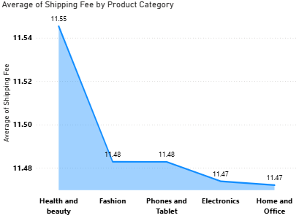

Insights and Recommendations:
- The shipping charges for all the product types are almost identical, ranging from 11.47 to 11.55. This indicates that the shipping charges do not vary significantly across these categories in our data.
- This could imply that the company uses a standardized shipping fee regardless of the product type, which is common in e-commerce businesses where flat rate shipping fees are applied for convenience.
- The minimal difference suggests that the shipping fees are either fixed or determined by factors other than the product type, such as the size, weight, or delivery location, rather than the product's category.
13. Come up with strategies to decrease the low rating orders after analyzing different factors like waiting time, shipping type, unit price, etc.
Ans. Visualization:
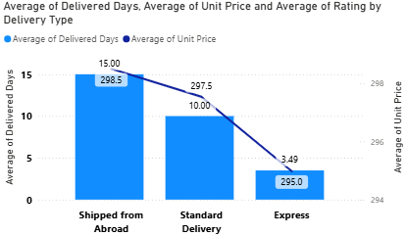

Insights:
- Longer wait times are associated with lower ratings, particularly for Shipped from Abroad deliveries.
- Express Delivery maintains relatively high ratings and having lower wait times, indicating that customers value speed.
- Standard Delivery with average wait times, leads to better ratings and suggesting customers appreciate faster delivery.
Recommendations:
a) Reducing Waiting Time:
- Optimize Inventory Placement: Use demand forecasting to place products in fulfilment center closer to high-order regions.
- Faster Order Processing: Automate picking and packing processes to reduce delays.
- Improved Order Tracking: Provide real-time tracking updates and estimated delivery time adjustments.
- Same-Day & One-Day Delivery: Expand these options for frequently purchased products.
b) Improving Shipping Type:
- Partner with More Logistics Providers: Increase efficiency by collaborating with local delivery partners.
- Reduce Last-Mile Delays: Use AI-powered route optimization and local delivery hubs.
c) Adjusting Unit Price Strategy:
- Dynamic Pricing: Use AI-driven pricing strategies to balance affordability with profitability.
- Bundle Offers & Discounts: Provide better value for money through bundled products or discounts on bulk purchases.
- Competitor Price Matching: Ensure prices remain competitive to increase perceived value.
d) Enhancing Product & Service Quality:
- Vendor Quality Control: Implement strict quality checks for third-party sellers.
- Customer Reviews Monitoring: Identify common complaints and address recurring issues.
- AI-Based Recommendation System: Show higher-rated products first to increase sales of quality items.
e) Customer Experience Improvements:
- Easy Return & Replacement Policy: A smooth return process builds trust and prevents negative reviews.
- Proactive Customer Support: AI chatbots and 24/7 support can resolve order issues before they result in low ratings.
- Loyalty Programs: Offer discounts or credits for customers who provide detailed feedback.
14. Using the time intelligence DAX function, create a table to compare each month’s sales with the previous year’s same month’s total sales. So there will be four columns in the output year, month, total sales, previous_years_sales.
Ans. Calculated Measures for PreviousYearSales1:
PreviousYearSales1 = CALCULATE([Total Revenue],SAMEPERIODLASTYEAR('Date'[Date]))
Visualization :
Column: Order date, Total Revenue, PreviousYearSales1
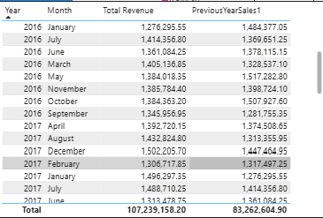
15. What do you understand by PowerBI gateway? What are its use cases?
Ans. Power BI Gateway is a bridge between on-premises data sources and Power BI in the cloud. It allows to schedule refreshes, connect to local databases, and ensure that Power BI reports are up-to-date.
Use Cases of Power BI Gateway:
- On-Premises Data Integration: For businesses with on-premises databases, the gateway enables seamless data transfer.
- Real-Time Data: Power BI Gateway allows you to provide real-time analytics.
- Security: Ensures secure data transfer between on-premises and cloud services.
- Hybrid Data Scenarios: Organizations can manage data both in the cloud and on-premises. The gateway supports hybrid setups, making it easier to analyse data across different environments.
- Integration with Other Services: It can be used with other Microsoft services like Azure Analysis Services and SQL Server Analysis Services, allowing for a seamless integration of analytics solutions
16. How would you approach this problem, if the objective and subjective questions weren't given?
Ans. If objective and subjective questions weren't provided in the given problem statement, here’s how I would approach the task:
Step 1) Data Exploration and Cleaning:
- I will start by exploring the dataset. Check the summary statistics to understand key trends. Look for missing values and handle them appropriately. Clean the data by standardizing categories and correcting any inconsistencies.

Step 2) Business Objective:

- Focusing on the objectives like boosting sales, optimizing delivery times, improving customer satisfaction, or enhancing product offerings and then identify the areas where business can improve its performance.

Step 3) Key Metrics:

- Now by focusing on some key metrics like total sales, customer satisfaction (ratings), product performance, and delivery efficiency that will help overall business and identify areas for improvement.

Step 4) Dashboard:

- Finally, creating visualizations that allow stakeholders to interact with the data. By designing the dashboards that provide insights into sales by product, region, and time. This will help the team drill down into the data and make informed decisions.

